HOME PAGE
1st Section: Video
The wording in video:
TRAVEL MORE, SPEND LESS.
Every Journey Tells a Story—Let Us Help You Create Yours
Book Your Dream Trip Today!

What we do:
Zoravia Terra Journeys plans and delivers stress-free travel experiences in Rwanda, specializing in wildlife safaris, gorilla trekking, chimpanzee tracking, cultural experiences, and tailor-made itineraries across Rwanda and East Africa for families, solo travelers, and groups.
We handle every detail from planning to on-ground coordination so our guests can enjoy their journey with confidence, comfort, care, and fun. Through our commitment to responsible and inclusive tourism, we actively collaborate with women-led and persons with disabilities (PWD) community initiatives, ensuring travel experiences create positive local impact
 (This tab should be in indigo written in white or tab in white words written white depending on the color of the background page. It has to be linked to our story section in about us tab)

Our services:
Our core services include gorilla trekking, wildlife safaris, chimpanzee tracking, Lake Kivu boat cruises, cultural and community-based tours, hiking and outdoor adventures, Kigali city tours, honeymoon packages, and corporate retreats across Rwanda.
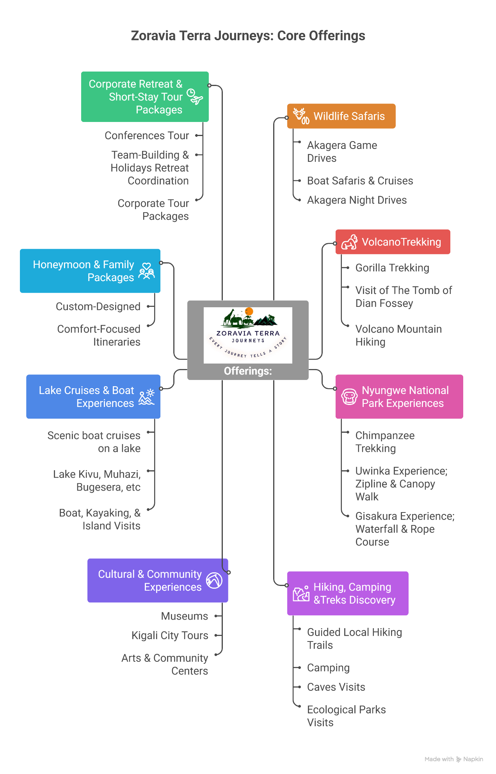
Why travel with us
(Be creative in displaying these)

Why Travel With Us
At Zoravia Terra Journeys, we turn our expertise and care into experiences you can trust. Here’s what sets us apart:
Seamless & Stress-Free Travel
From planning to return, we handle the details so you can focus on the journey.
Tailored Experiences
Every itinerary is crafted around your interests, fits, pace, and preferences.
Transparent & Honest Service
Clear pricing, upfront information, and open communication ensure confidence at every step.
Reliable On-Ground Support
Experienced guides and coordinators are ready to solve challenges and adapt plans in real time.
Responsible & Meaningful Travel
We design trips that respect local communities and ecosystems, letting you explore responsibly.
Convenience & Digital Access
Easy online booking and real-time updates keep you informed wherever you are.



ABOUT US:
Discover the Magic of Rwanda
Journeys Through a Thousand Hills, Layers of Time

Zoravia Terra Journeys Ltd specializes in customizable safaris, gorilla trekking, chimpanzee tracking, and cultural travel experiences in Rwanda, delivering seamless trip planning, trusted local expertise, and outstanding customer care from start to finish.
Our Story
(Be creative in displaying these)
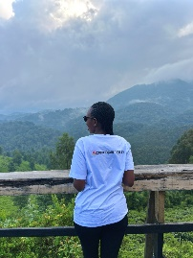
Zoravia Terra Journeys Ltd was founded at the intersection of personal passion, professional experience, and a commitment to service excellence.
For over five years, I worked in private sector development in Rwanda, supporting SMEs, startups, and cooperatives through business advisory services, project implementation, and capacity building. My work involved close collaboration with international organizations, government ministries, development agencies, and private sector actors, particularly in areas such as entrepreneurship development, business services, project management, and value chain strengthening, including the wood and creative industries.

Alongside my career, I’ve always had a passion for creating experiences and caring for people. From an early age, I enjoyed organizing events with attention to every detail, ensuring comfort, enjoyment, and genuine care in everything I do.
From this experience, I wanted to build a tour company that embodies high-quality service—consistency, transparency, accountability, and experiences that travelers can enjoy effortlessly. Tourism became a natural extension of my skills and passion.

I founded Zoravia Terra Journeys to bring the same professionalism and care I value in business to every journey. We design experiences that are thoughtfully planned, responsibly managed, and supported with clear communication and consistent customer care, while promoting sustainable practices and respecting the communities and ecosystems we visit.
Today, Zoravia Terra Journeys delivers stress-free, meaningful travel across Rwanda and East Africa guided with professionalism, integrity, and heart.

Our Values
(Be creative in displaying these)
🎯 Personalized Journeys
Every itinerary is tailored to your interests, preferences, and travel goals—moving beyond generic packages.
📱 Digital Convenience
Effortless booking, real-time updates, and mobile-friendly experiences make your journey seamless from start to finish.
🌿 Sustainability & Responsibility
We prioritize eco-friendly practices, support local communities, and protect the natural and cultural heritage of every destination.
💬 Transparency & Responsiveness
Clear, honest communication and proactive support ensure you feel informed, confident, and cared for at every step
Review???
(better way to show this is highly recommended)
Last section on this:
Add tab on booking or plan your next journey with us.
Travel With Us
Tailored Itineraries

PACKAGE 1

